The Transition to College for LGBTQ+ Youth: High School Experiences and College Plans

February 2026

Abstract
Limited research considers the diversity across gender identity and sexual orientation during the transition from high school to college. Drawing on the results of a large-scale survey (n = 9,230), we examine how college-bound LGBTQ+ students self-identify and explore patterns in students’ college expectations based on their high school experiences, including perceived concerns, ahead of college matriculation. Findings reveal there is a statistically significant difference between the high school experiences of cisgender students and transgender and gender expansive students, who report less positive experiences overall. Additionally, results from a principal component analysis indicate concerns about college can be divided into three constructs: general worries, worries about discrimination, and worries about financial burdens. While transgender and gender expansive students maintained higher levels of worry about discrimination overall, transgender students were more likely to report concerns about discrimination compared to other gender identities. Moreover, despite heightened concerns about discrimination, transgender and gender expansive students still planned to enroll in college at increased rates compared to their peers. These results emphasize the importance of identifying how high school experiences differ across gender identities to develop and strengthen support systems for students navigating the transition from high school to college.

Keywords: gender identity; college expectations; LGBTQ; mixed methods
The Transition to College for LGBTQ+ Youth: High School Experiences and College Plans
The transition from high school to college is a significant milestone for many young adults and can be a challenge for students learning to dually navigate new academic and social environments (Olson, 2017). As this transition is inherently shaped by one’s experiences in high school (Kurlaender et al., 2019; Reed et al., 2023; Uwah et al., 2008), it is important to examine the experiences and postsecondary expectations of students at that time. Moreover, transitions in and of themselves are critical periods in one’s educational trajectory, particularly for traditionally marginalized groups who may be more vulnerable (Perez & Farruggia, 2022). While literature on the transition to college has often drawn attention to emergent differences across subgroups (e.g., by race/ethnicity, income, first-generation status), limited research considers the significant diversity across gender identity and sexual orientation.
In fact, research indicates that lesbian, gay, bisexual, transgender, and queer (and/or questioning) (LGBTQ+) students face significant discrimination during high school and may experience diminished postsecondary outcomes, including access to college (Sanlo, 2004; Sansone, 2019). Additionally, data on this population of students is sparse, and studies tend to draw on historical data collected pre-pandemic (Austin et al., 2023; Kosciw et al., 2022; Reber & Smith, 2023; Sansone, 2019; Wilkinson et al., 2021), masking the more recent educational realities of students, particularly as experiences and outcomes are likely to vary over time (Mittleman, 2022). Moreover, education research often does not capture detailed information on gender identity and sexual orientation, inadvertently concealing the unique experiences of this population, including transgender students (Feldman et al., 2022; Goldberg & Kuvalanka, 2018; Mittleman, 2022). However, it is critical to consider the differences that may emerge during the high school to college transition, particularly for LGBTQ+ youth. This study overcomes several of these challenges by leveraging timely data from a large population of college-bound seniors that includes detailed information about their gender identity and sexual orientation.
This work thus aims to extend the literature on the experiences of LGBTQ+ high school students during matriculation in several ways. Drawing on the results of a large-scale survey conducted post-pandemic and in partnership with the state agency responsible for administering financial aid in California, we first examine how high school seniors describe their gender identity and sexual orientation. This study focuses on California students given the state’s broad diversity across demographics, geography, and postsecondary opportunities. We then explore patterns in high school experiences and college expectations (including academic plans, concerns, and excitements) using a mixed methods approach to investigate what trans and gender expansive students consider ahead of the transition to college. We specifically highlight this group of students as trans and gender expansive people face distinct social challenges other LGB+ people may not experience at the same rate (James et al., 2016). In this case, by examining trans and gender expansive students as a subgroup of the LGBTQ+ community, we are able to analyze potential inequalities they may experience and how this might influence the college transition process.
This article is organized as follows: First, we broadly review scholarship on gender identity and sexual orientation. We then situate our analysis within interconnected frameworks that center students’ situated contexts to account for the confluence of factors that may impact LGBTQ+ students’ college expectations and broader educational trajectory. Next, we outline our data sources and mixed methods approach, followed by our findings. Finally, we discuss the implications of these results and consider avenues for future research.
Defining Gender Identity and Sexual Orientation
Individuals use a variety of labels to describe both their gender identity and sexual orientation (Callis, 2014; Galupo et al., 2015), reflecting the fact that traditional binary labels (e.g., woman, man, heterosexual, homosexual) are often constraining descriptors for the complex ways individuals experience gender and sexuality (Hammack et al., 2022). Moreover, recent research suggests students are constructing their own identities through different labels (Watson et al., 2019; White et al., 2018). In this case, gender identities beyond the established binary are increasingly recognized and additional labels have also emerged to describe sexual orientation apart from those traditionally defined (Galupo et al., 2015). Although individuals continue to identify with traditional binary labels, many students now use a more expansive set of labels for both gender (e.g., nonbinary, genderfluid) and sexual orientation (e.g., asexual, queer) (Beemyn, 2022; Hammack et al., 2022). Additionally, not every individual may feel comfortable selecting a label, or may be unsure about which labels to select, with questioning and unsure commonly reported terms for both gender identity and sexual orientation (Watson et al., 2019; White et al., 2018). In this study, we utilize a novel dataset to acknowledge the spectrum of labels students may use to define their identities outside a binary construct and spotlight transgender, nonbinary, and gender diverse students in our analysis to enrich understanding of these students’ unique experiences navigating the high school to college transition.
Theoretical Background and Prior Literature
There are several factors that may influence how a student navigates the transition from high school to college, as it is a period shaped by a confluence of individual and institutional factors that may affect students’ educational expectations and later attainment (Kurlaender et al., 2019). In fact, one’s individual differences, relationships, the school one attends, and broader context and surroundings all play a role during this critical period (Luh et al., 2023; Pike & Robbins, 2016). At the student level, students’ individual attributes, such as motivation, self-efficacy, and academic performance, moderate their educational trajectory. For example, differences in motivation and self-efficacy are likely influenced by shifting social norms related to college-going as well as one’s school environment and the messages it sends (or doesn’t) about college, all of which can impact expectations and effort. In fact, research indicates that motivation is predictive of academic performance, higher quality work, and persistence across K-12 to postsecondary education (Casillas et al., 2012; Lazowski & Hulleman, 2016), while self-efficacy (the belief that one’s abilities may affect one’s outcomes in life) can influence goals, effort, and how one navigates educational expectations and challenges (Bandura, 1981). Moreover, academic performance is associated with aspirations to both two- and four-year colleges (DesJardins et al., 2019), suggesting that students’ perceptions of their chances of admission and success also guide their postsecondary ambitions.
Additionally, research has long demonstrated that various forms of social and cultural capital play a major role in shaping students’ educational pathways (Bourdieu, 1986; Dumais & Ward, 2010; Merolla & Jackson, 2014; Plagens, 2011; Wells, 2008). For example, social capital (the resources available through one’s social networks) reveals how relationships with peers, family members, and others can support students’ acquisition of valuable information about the college application and enrollment process and develop stronger college-going attitudes and behaviors (Alvarado & An, 2015; Hill, 2008; Skobba et al., 2018). In this case, students that can navigate the socially constructed norms surrounding the college process, and whose networks provide access to academic and social resources for this transition, are more likely to enroll in college (Choi et al., 2008; Fletcher, 2015). As LGBTQ+ students often experience hostile social environments in schools and at home, caring adults and social support more broadly may be particularly important to the college-going process. Beyond social capital, research suggests that LGBTQ+ students living in cis-normative environments exhibit particular strengths, or several types of queer cultural capital (Pennell, 2016). This includes navigational capital, or the ability to navigate schools and other institutional systems that are not always designed with LGBTQ+ students in mind. In this case, students must learn to navigate systems and spaces (e.g., cis-normative school and state policies about gendered restrooms, sports participation), potentially in creative ways, in order to access the psychological, social, cultural, and physical resources they need for their well-being (Pennell, 2016).
At the institutional level, schools shape students’ expectations of college and future educational attainment through the environments they cultivate (Eccles & Roeser, 2011; Uwah et al., 2008). A school culture characterized by high values and expectations for learning is associated with increased academic outcomes (Hattie, 2009), and school safety and climate are also critical to engagement, belongingness, and achievement (Osterman, 2000; Walton & Cohen, 2011). As schools may be unsafe learning environments for LGBTQ+ students, who often experience higher rates of bias-based bullying and victimization (Day et al., 2018), LGBTQ+ students’ perception of school climates may be inherently different than their cisgender heterosexual peers. Moreover, students’ schooling experiences are mediated by stressors that underlie societal conditions, including external (e.g., discrimination and violence) and internal stressors (e.g., expectations of prejudice, concealment, internalized stigmas). These stressors, heightened for LGBTQ+ students, can have an effect on psycho-social outcomes (Hunter et al., 2021), ultimately influencing educational expectations and the transition from high school to college more broadly. For example, prior research indicates that transgender youth often experience gender-related victimization, particularly in secondary schools, which may lead to higher levels of emotional distress and lower levels of school belonging (McBride, 2021). Moreover, victimization, reduced feelings of school belonging, and emotional distress can have a negative effect on school attendance, academic performance, and expectations to enroll in a four-year college for all LGBTQ+ youth (Aragon et al., 2014). Altogether, research suggests students’ situated contexts can influence their future educational behavior (Gong & Toutkoushian, 2024).
Our work is thus motivated by several interconnected frameworks to understand how LGBTQ+ students navigate the transition from high school to college. First, we draw on a new model of college choice outlined by Klasik and colleagues (2025) that builds upon prior models (e.g., Hossler & Gallagher, 1987; Perna, 2006) to include expectations as a critical component in students’ predisposition for college. Here, the authors make the distinction that while aspirations are inherently foundational to the college choice process, they often reflect what one may want in an ideal world. In contrast, expectations are foregrounded in the present, and as such are flexible to new information and outside influences, thereby incorporating students’ situated context, including individual, social, and environmental factors (Klasik et al., 2025). Moreover, expectations color all other elements in the model (academic preparation, information seeking, college knowledge, application, and enrollment), as they underpin whether (and where) a student will enroll in college. As expectations will differ for different students and may evolve over time, we examine the ways in which high school experiences influence students’ college expectations (including academic plans, concerns, and excitements) in the spring of their senior year and focus on an understudied and marginalized group: LGBTQ+ students.
As college expectations are context-dependent, this study also uses a social ecological theory of resilience (Ungar, 2011, 2012) as a guiding framework to understand the potential variation in the college expectations of LGBTQ+ students, who must often navigate hostile environments and cis-normative policies at school and within society more generally (Kosciw et al., 2022). In this case, a social ecological theory of resilience accounts for the person, their environment, and the interaction between them (Ungar, 2011, 2012), as what may be considered an adversity for one student in a particular context may not put another at risk. At the same time, the converse may also be true, in that what may be a positive experience for one student in one context may not be similarly felt by another. For example, experiences of bullying, victimization, and violence might negatively impact the postsecondary enrollment plans of LGBTQ+ youth, but not necessarily in predictable ways. LGBTQ+ students often develop coping skills through access to LGBTQ+ community spaces and other supportive resources (Feldman et al., 2022), which can lead to collective action, a sense of purpose, and personal growth (DiFulvio, 2011; Riggle et al., 2011), allowing students to carve out personalized pathways to resilience (Asakura, 2017). This in turn may bolster students’ desires to enroll in college in search of a similar, better, or perhaps safer space to learn than their high school environment. This could also include the field they intend to study; for example, research indicates that LGBTQ+ students are more likely to pursue arts and humanities majors, as students feel these fields are more affirming (Linley et al., 2018) and more inclusive than STEM or business (Forbes, 2022; Kersey & Voigt, 2021)—a decision that may be tied to overall sense of belonging and students’ search for a safe space. Moreover, LGBTQ+ youth that struggled socially in high school may look towards college as a new opportunity to fit in, while those who did not struggle as much may have other concerns. Similarly, LGBTQ+ students that plan to live away from home while in college may feel increased trepidation (i.e., leaving familial support) or, in contrast, relief (i.e., escaping familial discomfort or hostility). As college transitions vary across demographic differences, including gender (Means et al., 2016; Toutkoushian et al., 2018), students’ identities concurrently influence their lived experiences and expectations for their pathway to college (Feldman et al., 2022; Fotopoulou, 2012). Therefore, it is important to consider different elements of students’ identities in addition to how those identities are shaped by students’ networks and environment. In this case, the differences we observe in LGBTQ+ students’ expectations for college will reflect students’ experiences and the ways in which they navigate their own situated context.
Data and Methods
Survey Instrument and Sample Characteristics
In May 2023, in partnership with the California Student Aid Commission (CSAC)—the state agency responsible for administering financial aid programs for students attending public and private universities, colleges, and vocational postsecondary institutions in California—we administered a web-based survey to document the experiences of high school seniors planning to enroll in college. The survey was distributed to all seniors statewide that submitted either the Free Application for Federal Student Aid (FAFSA) or the California Dream Act Application (CADAA) for the 2023-24 academic year.¹ Students reported on varying dimensions of their high school experiences; the support they received in preparation for college; their academic interests and plans for postsecondary enrollment; and their concerns about college. Using validated instruments (Badgett et al., 2009), detailed information on gender identity and sexual orientation was also collected. Overall, our sample includes 9,230 respondents who indicated they were high school seniors that intended to enroll in college that fall. Table 1 reports the demographic characteristics of our analytical sample.

Table 1
Summary Statistics
 | Freq. | Percent
Panel A. Gender identity
Cisgender man | 2,675 | 35.56
Cisgender woman | 4,289 | 57.02
Transgender man | 59 | 0.78
Transgender woman | 20 | 0.27
Nonbinary | 267 | 3.55
Gender diverse/questioning | 71 | 0.94
Prefer not to say | 141 | 1.87
Total reported gender identity | 7,522 | 100.00
Panel B. Sexual orientation
Straight/heterosexual | 5,190 | 69.38
Gay or lesbian | 330 | 4.41
Bisexual/pansexual/omnisexual | 1,139 | 15.23
Asexual/aromantic/demisexual | 182 | 2.43
Other/queer/questioning | 131 | 1.75
Prefer not to say | 509 | 6.80
Total reported sexual orientation | 7,481 | 100.00
Panel C. Race/ethnicity
American Indian/Alaskan Native | 163 | 2.14
Black/African American | 532 | 6.99
Hispanic/Latinx | 3,793 | 49.82
Pacific Islander | 64 | 0.84
Filipino | 235 | 3.09
Asian | 1,146 | 15.05
Other | 182 | 2.39
White/Non-Hispanic | 1,498 | 19.68
Total reported race/ethnicity | 7,613 | 100.00
Panel D. Highest level of education among parents
Did not complete high school | 1,373 | 18.11
High school diploma | 1,578 | 20.81
Some college, no college degree | 975 | 12.86
Associate degree | 452 | 5.96
Bachelor's degree | 1,363 | 17.97
Graduate/Professional degree | 1,455 | 19.19
Don’t know | 387 | 5.10
Total reported parental education | 7,583 | 100.00
Note. Sample only includes college-going high school seniors. Of the total (n = 9,230), 1,708 respondents did not report gender identity; 1,749 did not report sexual orientation; 1,617 did not report race/ethnicity; and 1,647 did not report level of parental education.
To collect data on gender identity, we adopted the two-step approach recommended by the Williams Institute given its high sensitivity, specificity, and increased reliability in accurately capturing transgender respondents (Saperstein & Westbrook, 2021; The GenIUSS Group, 2014). This approach includes two questions: (1) What is your sex assigned at birth, on your original birth certificate?, with male and female as response options; and (2) What is your current gender identity?, with woman, man, nonbinary, prefer not to say, and other as response options. Respondents who chose other also had the option to write in a response. Using these survey items, we classify respondents into one of the following umbrella categories: cisgender, transgender and gender expansive (Robinson & Cooper, 2024), and prefer not to say. Respondents who reported that their sex assigned at birth aligned with their current gender identity (e.g., male and man; female and woman) were categorized as cisgender, while respondents who reported their sex assigned at birth differed from their current gender identity were categorized as trans(gender) and gender expansive. The Human Rights Campaign uses the term trans(gender) and gender expansive to describe “the collective community of individuals whose gender identities, gender presentations and expressions, and/or lived experiences differ from those typically associated with the sex they were assigned at birth” (Robinson & Cooper, 2024). Here, we adopt this collective umbrella term to refer to all respondents who identified differently than their sex assigned at birth while recognizing that “trans” and “gender expansive” are not necessarily distinct or mutually exclusive identities, and that some may not use these labels to describe their personal identity.
We further classify trans and gender expansive students into the following sub-categories, which we utilize in our analysis: transgender men, transgender women, nonbinary, and gender diverse/questioning. For example, students who reported their sex assigned at birth as female or male and who identified as a man or a woman were categorized as binary-identifying transgender men and women, respectively. Students who selected nonbinary or wrote in responses that included the term “nonbinary” in their written responses were categorized as nonbinary, regardless of sex assigned at birth. Students who wrote in other diverse gender identities (e.g., genderfluid, agender, genderqueer) are captured by the term gender diverse/questioning. Our analysis revealed some significant differences between the experiences of nonbinary and gender diverse/questioning students, which provides additional support for these distinctions. Finally, students who chose prefer not to say or wrote in malicious responses were classified as prefer not to say.
To measure sexual orientation, we adapted the survey instrument recommended by the Williams Institute to capture the breadth of students’ identities. Students were asked to self-identify among the following options: lesbian or gay; straight (not gay or lesbian); bisexual; asexual; prefer not to say; and other, which also included the opportunity to write in a response (The GenIUSS Group, 2014). In this case, the option asexual was added to proffer more expansive options for students.
Data Analysis
To investigate how high school seniors describe their identities and explore how school experiences may shape the plans of college-bound LGBTQ+ youth, we leverage a mixed methods approach. We begin with a descriptive examination of the open-ended responses provided by students to describe their gender identity and sexual orientation. We then take a closer look at gender identity in particular to better understand patterns in high school experiences and college plans across student subgroups. Additionally, we examine students across identity groups through regression and principal component analysis (PCA)² and apply a qualitative lens to students’ open-ended responses.
Quantitative Analysis
We examine a series of closed-ended Likert-scale survey questions to understand if students’ worries about the transition to college are mediated by their gender identity through PCA and regression. First, we identify the number of dimensions of students’ worries about the college transition using PCA, incorporating each survey item related to concerns about college. Analysis revealed three distinct constructs to students’ worries about college, which we detail later in our findings.³ We then use regression analysis to estimate the differences in each construct of worry by gender identity. We estimate three different specifications in our analysis: (1) an unconditional model with the gender categories alone; (2) a model controlling for student demographics (i.e., the full set of race/ethnicity and parental education indicators); and (3) a model that controls for student demographics and a construct of students’ reported high school experiences. We also use PCA to explore dimensionality in students’ high school experience. Results from the PCA identified strong reliability⁴ for one construct of high school experience, which we created as an index variable based on a series of questions students were asked about their high school academic, social, advising, and college preparation experiences; we include it as a linear continuous variable in the regression model.⁵
Qualitative Analysis
The survey also asked respondents two open-ended questions: (1) What do you think is the biggest challenge you’ll face in college?; and (2) What are you most excited about for college? Data was imported into MaxQDA 2022 from respondents who indicated: (1) a gender identity categorized as transgender, nonbinary, or gender diverse/questioning; and (2) plans to attend college in the fall of 2023.⁶ Both open-ended questions were thematically coded to identify common challenges (Table 5) and excitements about college (Table 6). Themes were identified through a combination of open and descriptive coding by the authors and finalized upon mutual agreement; in the event students described several challenges or excitements in their responses, these were categorized across multiple themes. For example, if a student identified both financial challenges as well as trouble making friends, the response was coded as both financial and social. After completing a first round of coding, each main code was reevaluated to review coded segments and constructed subcodes, identifying challenges and excitements within overall categories (e.g., academic).
Findings
Student Identity
Our first aim was to better understand how high school seniors described their gender identity and sexual orientation. Beyond the survey options provided (man, woman, nonbinary), respondents could also write-in responses. These responses are displayed in Figure 1, in which the size of the word corresponds to the frequency of its use.⁷ In this case, gender identity responses highlighted a rich diversity in how college-bound California high school seniors identified. Beyond predefined options, students denoted 26 unique terms to describe their gender identity that spanned the gender spectrum, with most write-in respondents identifying as genderfluid or agender. Other terms included bigender, genderqueer, and two-spirit, among many others. Several respondents also communicated uncertainty or questioning of their gender identity—using variations of the terms questioning, uncertain, and unknown.

Figure 1
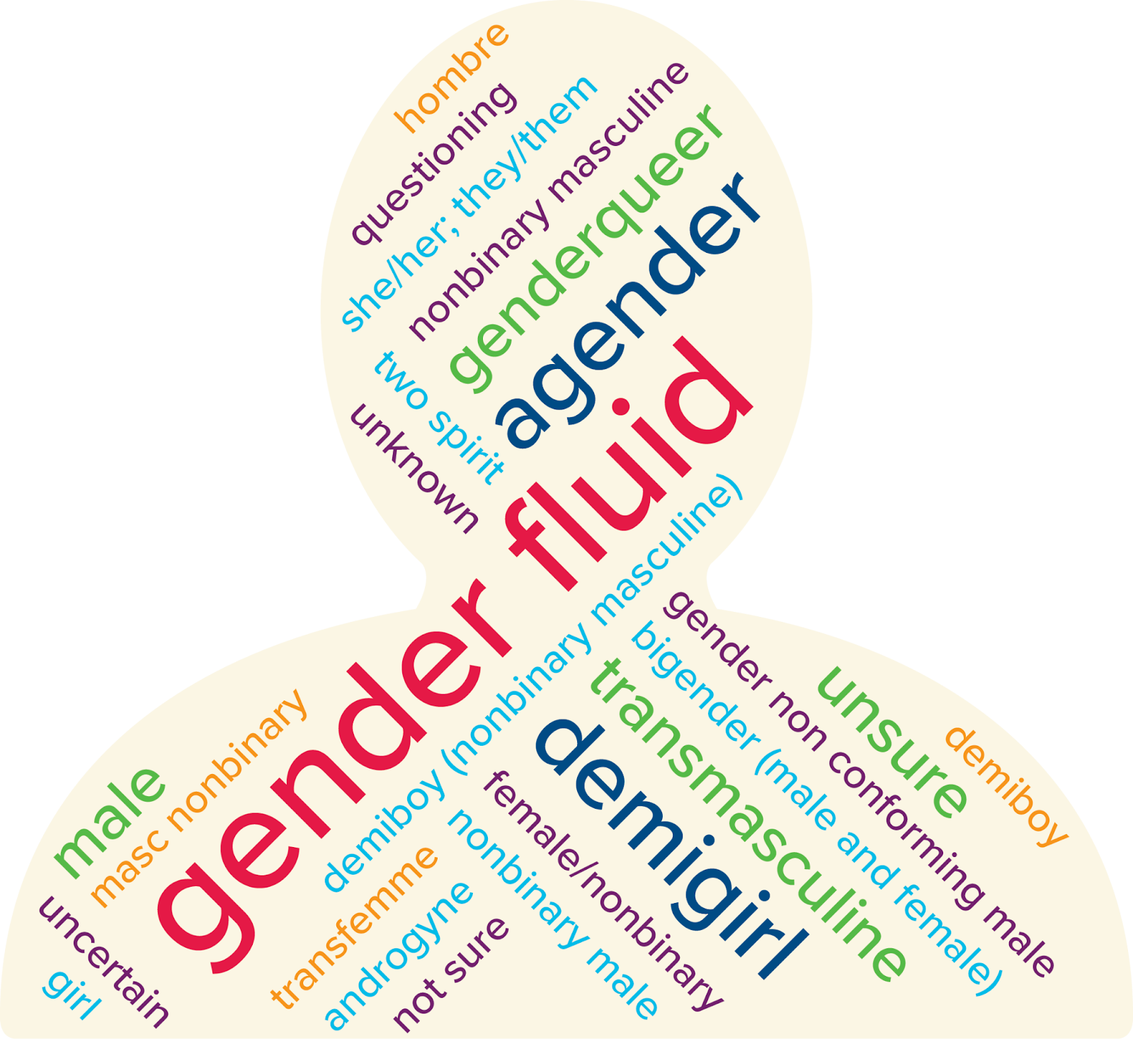
Gender Identity Word Visualization
Note. The size of the terms displayed are proportional to the frequency of their use.
Students also used a variety of terms to describe their sexual orientation beyond those provided (Figure 2).⁸ The most common write-in labels were pansexual and queer, while several students noted questioning or unsure or did not want to label their sexual orientation. A number of students also used multiple terms, such as omnisexual and demisexual; bisexual and asexual; and asexual and queer. Additionally, several students used multiple sexuality labels to recognize a distinction between their sexual and romantic attraction.

Figure 2
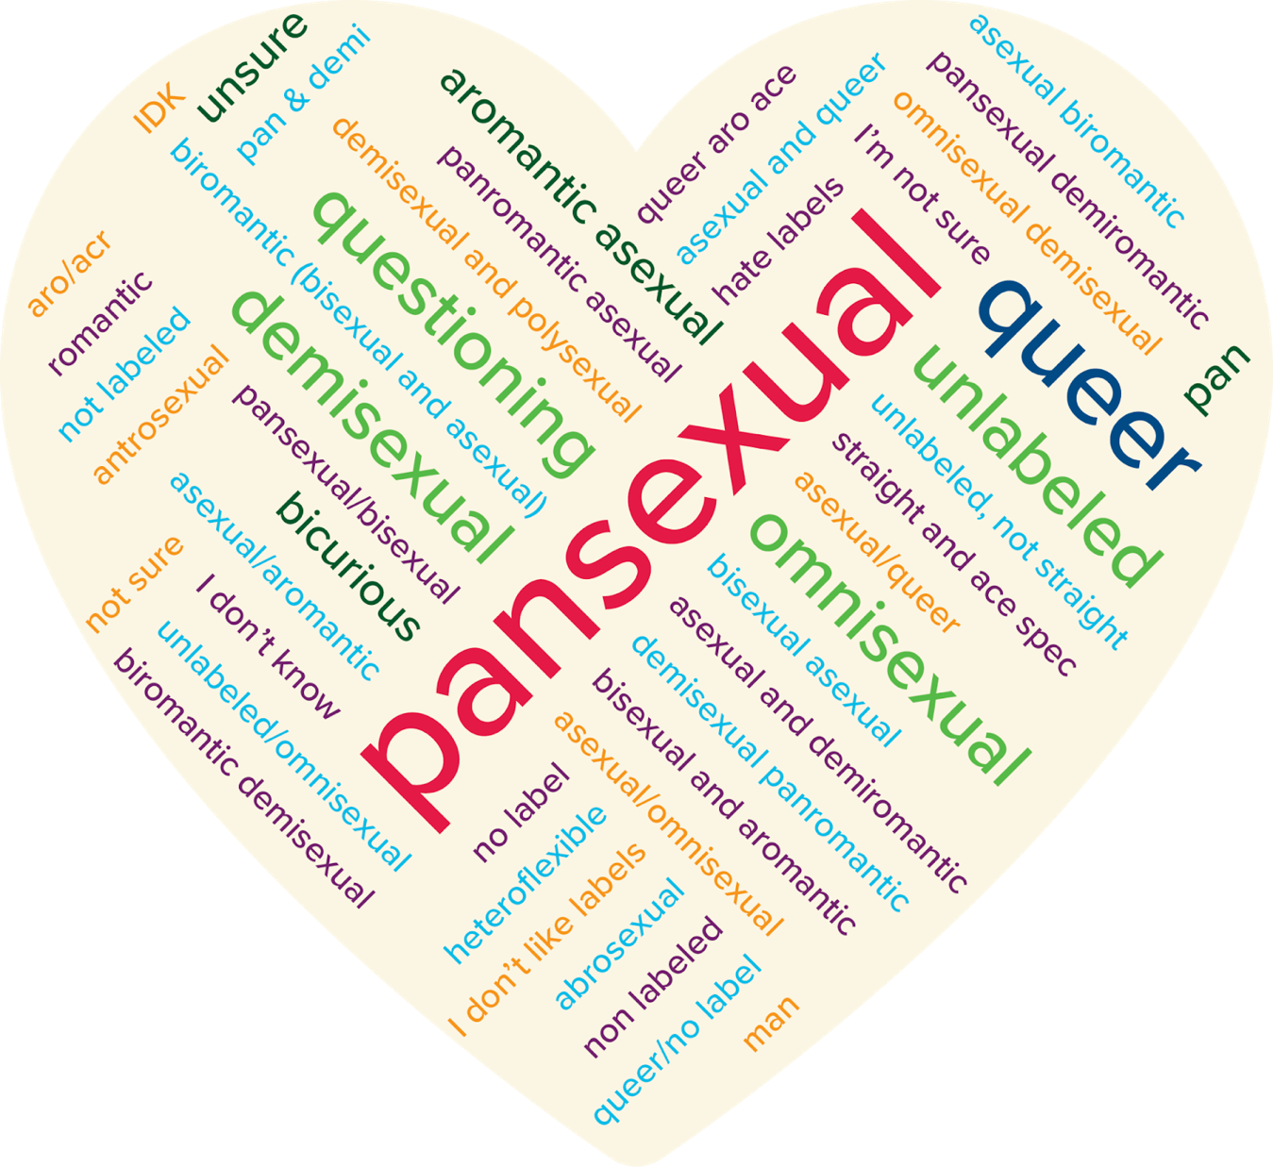
Sexual Orientation Word Visualization
Note. The size of the terms displayed are proportional to the frequency of their use.
We also examined associations between gender identity and sexual orientation and found that trans and gender expansive students were more likely to select a non-heterosexual sexual orientation than cisgender students (see Appendix A).
Academic Plans
In the remainder of our analysis, we focus on gender identity to explore patterns in the academic plans among trans and gender expansive students, including program type, intended field of study, and the highest degree students planned to pursue. Most students planned to enroll in a four-year college compared to a two-year, regardless of gender identity (Figure 3); however, transgender and nonbinary students planned to enroll in four-year colleges at much higher rates compared to their cisgender peers. Conversely, students that identified as gender diverse or questioning were about as likely to enroll in a two-year or four-year college (49.3% and 50.7%, respectively).
Figure 3
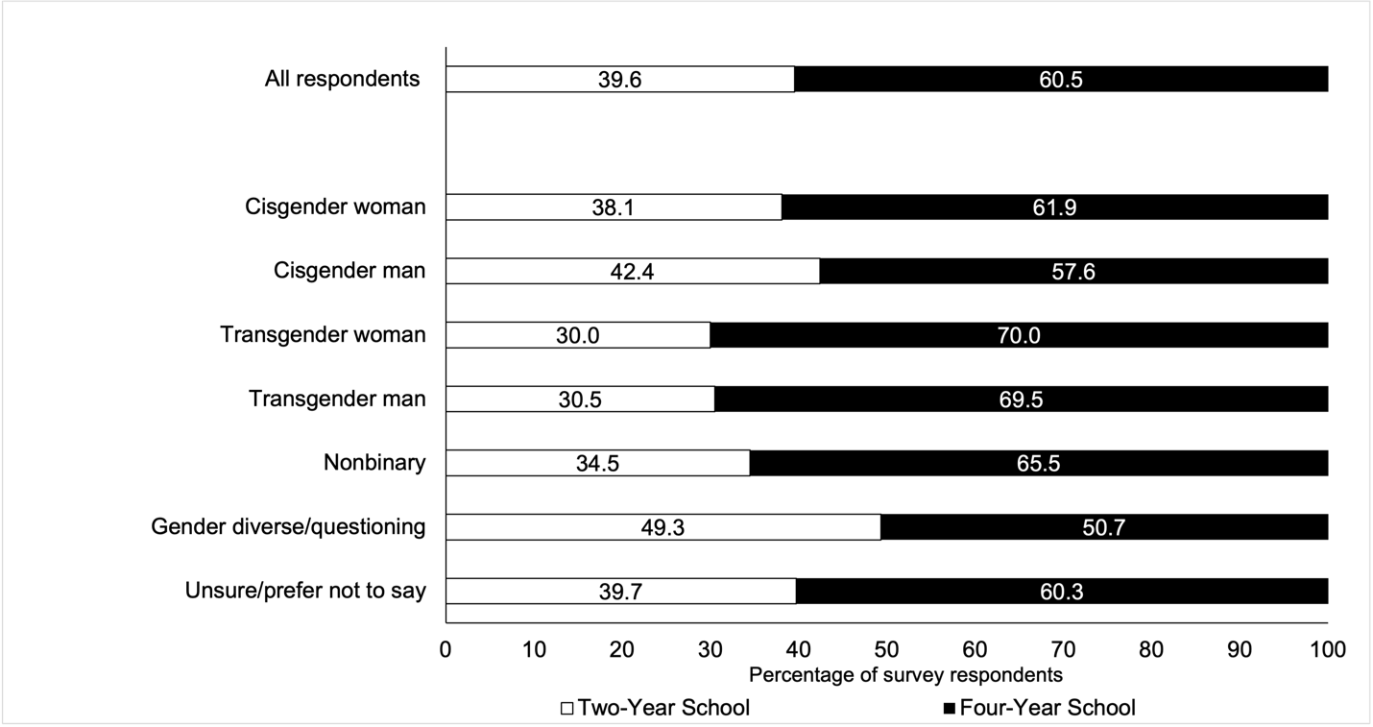
Plans for College Enrollment
Note. Rates depicted in the figure represent 7,522 respondents who indicated plans to attend college. Of the full sample (n = 10,221), 9,230 respondents indicated they planned to go to college, 170 did not plan to attend, 294 were unsure, and 527 did not respond.

Differences also emerged in students’ intended field of study (Table 2). Overall, most students planned to study natural sciences (16.3%), engineering (16.2%), and health sciences (14.8%), including trans and gender expansive students. In this case, these students often selected these majors at higher rates than their peers. For example, transgender women planned to study engineering at nearly 9 percentage points above the rate overall. Trans and gender expansive students were also more likely to pursue humanities and the arts, as gender diverse students (31%), transgender men (28.8%), nonbinary students (25.5%), and transgender women (25%) all indicated this field at much higher rates than its rate overall (11.4%). Moreover, fewer trans and gender expansive students were undecided about their major compared to their cisgender peers.
Table 2
Intended Field of Study by Gender Identity
 | Business | Engineering | Natural sciences | Social sciences | Humanities and arts | Health sciences | Education | Applied sciences | Public service | Undecided | N
All respondents | 10.0 | 16.2 | 16.3 | 12.3 | 11.4 | 14.8 | 3.5 | 3.4 | 4.8 | 7.5 | 7,499
Cisgender man | 12.1 | 30.0 | 12.2 | 7.9 | 8.9 | 8.0 | 1.4 | 7.0 | 4.3 | 8.4 | 2,662
Cisgender woman | 9.6 | 7.8 | 18.4 | 14.7 | 11.2 | 19.9 | 4.9 | 1.2 | 5.3 | 7.1 | 4280
Transgender man | 1.7 | 13.6 | 22.0 | 15.3 | 28.8 | 6.8 | 5.1 | 1.7 | 1.7 | 3.4 | 59
Transgender woman | 10.0 | 25.0 | 10.0 | 10.0 | 25.0 | 0.0 | 0.0 | 15.0 | 0.0 | 5.0 | 20
Nonbinary | 3.0 | 12.0 | 19.9 | 15.4 | 25.5 | 7.9 | 3.0 | 3.4 | 3.4 | 6.7 | 267
Gender diverse/  questioning | 1.4 | 9.9 | 19.7 | 16.9 | 31.0 | 8.5 | 1.4 | 1.4 | 5.6 | 4.2 | 71
Prefer not to say | 5.0 | 19.3 | 18.6 | 12.9 | 17.9 | 9.3 | 2.9 | 2.1 | 3.6 | 8.6 | 140
N | 749 | 1211 | 1220 | 920 | 852 | 1106 | 262 | 255 | 360 | 564 | 7,499
Note. The rates depicted represent 7,499 respondents who indicated their intended field of study. Each cell represents the row percentage.

Students also indicated the highest degree they planned to complete (Figure 4). Across all respondents, over half planned to earn an advanced degree. Additionally, we find trans and gender expansive students planned to earn a master’s or a doctorate at higher rates compared to cisgender students. Among transgender women, of the 55% that planned to complete an advanced degree, 40% intended to earn a master’s degree—over six percentage points higher than any other gender identity we surveyed. Comparatively, transgender women, gender diverse/questioning students, and cisgender men were more likely to pursue an associate or vocational degree compared to other students, although transgender women and cisgender men appear to be outliers overall. This may be due to students’ situated context and the potential barriers they might encounter (e.g., financial constraints, a lack of information), which can drive students to various degree pathways. For example, a student may perceive a mismatch between their ability level and certain colleges (Dillon & Smith, 2013), or have concerns about college (e.g., campus climate) (Dugan et al., 2012), among other explanations, driving them to select (or avoid selecting) a particular institution or pursuing a more advanced degree.
Figure 4
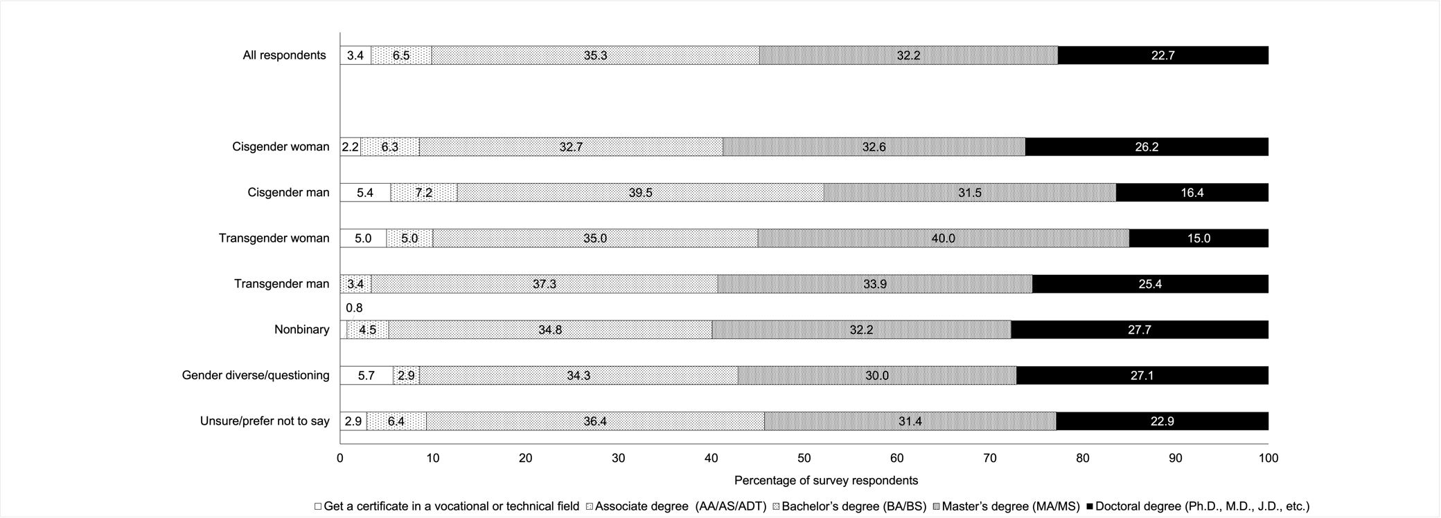
Plans for Degree Completion
Note. Rates depicted in the figure represent 7,497 respondents who indicated plans for degree completion.

High School Experiences
Students were also asked about their academic and social experiences in high school. We constructed an index for these experiences and compared average high school experiences by gender identity.⁹ In this case, a positive value denoted an overall positive experience, a negative value indicated an overall negative experience, while zero suggested a neutral experience in high school. Additionally, a larger index value indicated a higher rating of high school experience. In Table 3, we present the average general high school experience construct for each gender identity category. We tested whether these differences were statistically significant and found that cisgender men report the most positive high school experiences compared to students of other gender identities. Conversely, trans and gender expansive students reported less positive high school experiences compared to their cisgender peers, particularly students that identify as gender diverse/questioning. We plotted these differences in Figure 5 and found them statistically significant and robust to the inclusion of demographic controls. While not causal, these results indicate that there is an association between gender identity and students’ experiences in high school, which we then consider in later analyses.

Table 3
General High School Experience by Gender Identity
 | Freq. | General high school experience index
Cisgender man | 2,659 | 4.271
Cisgender woman | 4,269 | 3.787
Transgender man | 59 | 2.424
Transgender woman | 20 | 2.55
Nonbinary | 267 | 2.318
Gender diverse/questioning | 71 | 1.113
Prefer not to say | 138 | 2.232
Total | 7,483 | 3.839
Note. The general high school experience index only applies to students who reported non-missing values for all six high school experience items and ranges from -12 to 12 (negative values indicate a negative experience, positive values indicate a positive experience, and zero indicates a neutral experience). High school experience items are available in Appendices B and C.

Figure 5
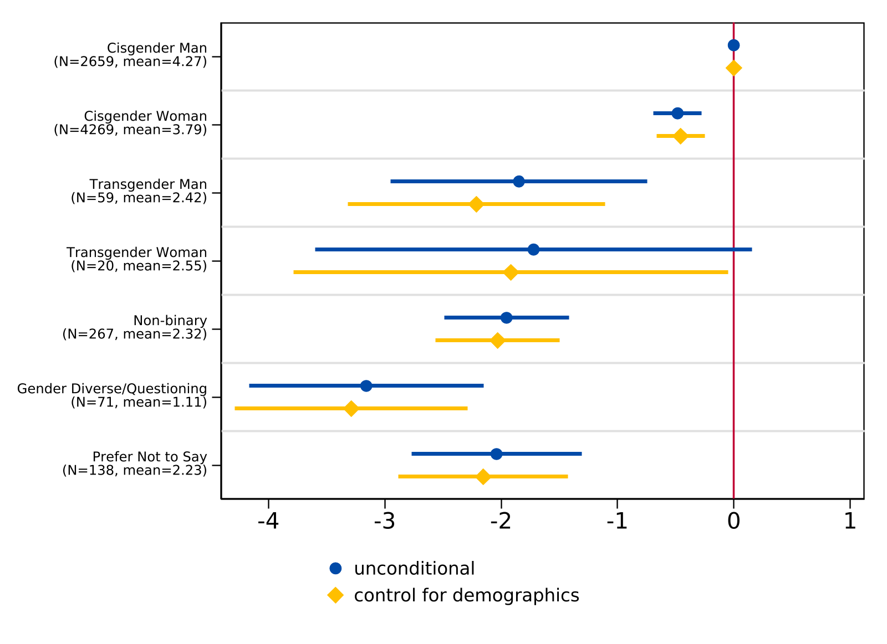
Regression of Overall High School Experience on Gender Identity Categories
Note. For the unconditional model, n = 7,483. For the model controlling for demographics (race/ethnicity and parental level of education), n = 7,464. The lines indicate 95 percent confidence intervals while the sample frequency and mean index of each gender identity are reported in parentheses. The vertical line at 0 represents the coefficient for the reference group (cisgender man).

Concerns About College Experiences
Students also described their concerns ahead of the transition to college (Table 4). Answers to each question ranged from 0 to 3, in which a higher value corresponded with a higher level of concern. Using PCA, we found that students’ worries about the transition to college can be divided into three dimensions: (1) general worries; (2) worries about discrimination (including gender, sexuality, race, and religion); and (3) worries about financial burdens (including tuition and living costs). Together, these components explained 56% of the variance in overall worries about the transition to college. We constructed three indices of worries using PCA eigenvectors (summary statistics of the PCA constructs are reported in Table 4).

Table 4
College Concern Items and Results from Principal Component Analysis (PCA)
 | N | Mean
Items:
How worried are you about…
Affording tuition fees? | 7,957 | 1.827
Living expenses? | 7,956 | 1.676
Performing well academically? | 7,958 | 1.502
Balancing work obligations? | 7,943 | 1.557
Balancing family obligations? | 7,941 | 1.055
Finding community? | 7,934 | 1.316
Living away from home? | 7,948 | .908
Having adequate support for emotional and mental health needs? | 7,944 | 1.127
Discrimination based on gender? | 7,886 | .436
Discrimination based on sexual orientation? | 7,876 | .333
Discrimination based on race? | 7,895 | .514
Discrimination based on religion? | 7,891 | .232
PCA Constructs:
General worries (32.03%) | 7,706 | 3.776
Worries about discrimination (13.79%) | 7,706 | -1.219
Worries about financial burdens (10.26%) | 7,706 | .634
Note. The first twelve rows are survey items related to college worries. Each item ranges from 0 (not worried at all) to 3 (very worried). The last three rows indicate the three constructs: (1) general worries ranges from 0 to 10.23; (2) worries about discrimination ranges from -3.83 to 5.12; and (3) worries about financial burdens ranges from -3.64 to 3.65. Constructs were only created for high school students that reported non-missing values for all twelve items. The PCA proportion explained is reported in parentheses after each construct. For college concern items by gender identity, see Appendix D.
In terms of broad concerns, we find trans and gender expansive students experience a higher level of general worries compared to cisgender students. When we correlated these worries to students’ high school experiences, there appeared to be a negative, fairly weak correlation between high school experience and general worries about college; that is, students who reported more negative experiences in high school, on average, reported more worries. However, there is almost no correlation between high school experience and worries about discrimination or financial burdens, respectively.
Figures 6 through 8 present ordinary least squares (OLS) regression estimates for each component of worry by gender identity both with and without controls for high school experiences and demographics. In all regressions, cisgender men was set as the baseline comparison category. The point estimates represent the difference in a component of worry for each gender identity relative to cisgender men. The blue dots show the point estimates of the unconditional OLS estimates, while the yellow dots indicate OLS estimates that include race/ethnicity indicators, parental education indicators, and the constructed high school experience index as covariates. The lines represent 95% confidence intervals, which indicate if the estimated difference is statistically significant from cisgender men.
Regression estimates for general college worries on gender identity categories are presented in Figure 6. Among trans and gender expansive students, we find no statistical differences in general worries between different gender identities. That is, the general worries of transgender men, transgender women, and nonbinary or gender questioning students was significantly lower than cisgender men, but not significantly different from each other.
Figure 6
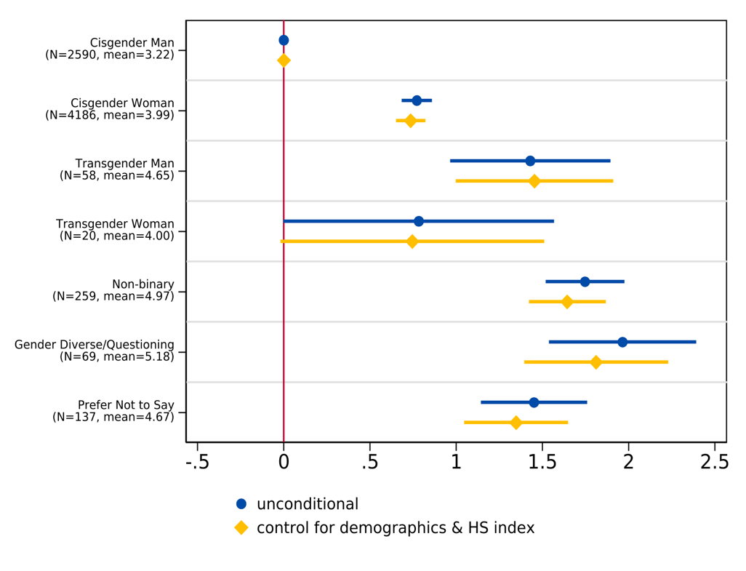
Regression of General College Worries on Gender Identity Categories
Note. We estimate regression models with gender indicators for an unconditional model (n = 7,319) and include race/ethnicity indicators, parental education indicators, and a constructed high school experience index as covariates for the specification with control variables (n = 7,276). The lines indicate 95 percent confidence intervals while the sample frequency and mean for each gender identity are reported in parentheses. The vertical line at 0 represents the coefficient for the reference group (cisgender man).

Additionally, results illustrate that trans and gender expansive students maintain higher levels of worry about discrimination compared to cisgender students (Figure 7), as the magnitude of the difference between transgender men and cisgender men exceeds the mean level of worry about discrimination for cisgender men. Additionally, among trans and gender expansive students, transgender students report higher levels of worry about discrimination compared to nonbinary and gender diverse/questioning students, although this estimate is somewhat noisy due to sample size. Finally, Figure 8 suggests that worries about financial burdens do not differ by gender identity.
Figure 7
Regression of Worries about Discrimination on Gender Identity Categories
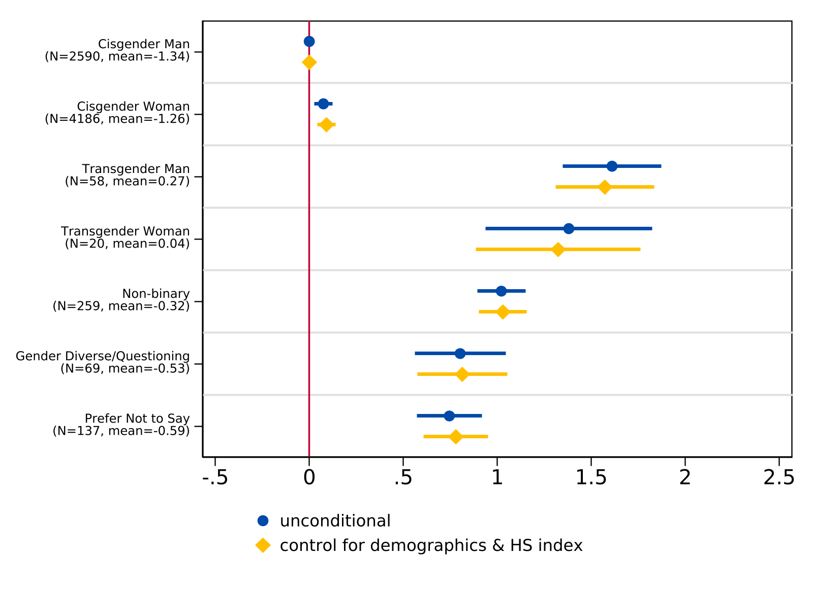
Note. We estimate regression models with gender indicators for an unconditional model (n = 7,319) and include race/ethnicity indicators, parental education indicators, and a constructed high school experience index as covariates for the specification with control variables (n = 7,276). The lines indicate 95 percent confidence intervals while the sample frequency and mean for each gender identity are reported in parentheses. The vertical line at 0 represents the coefficient for the reference group (cisgender man).

Figure 8
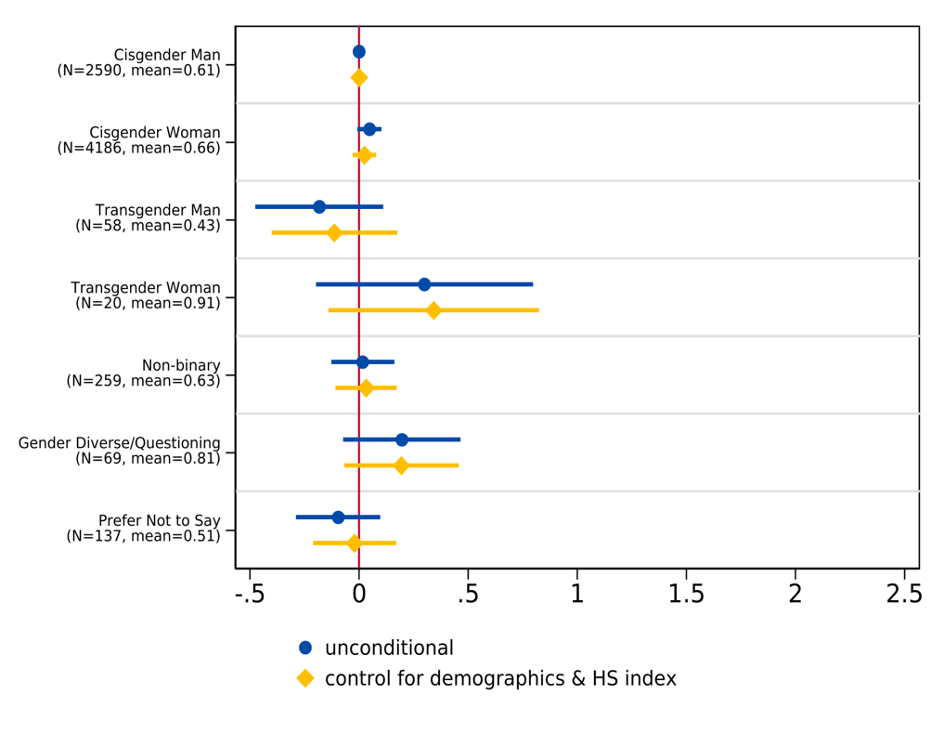
Regression of Worries about Financial Burdens on Gender Identity Categories
Note. We estimate regression models with gender indicators for an unconditional model (n = 7,319) and include race/ethnicity indicators, parental education indicators, and a constructed high school experience index as covariates for the specification with control variables (n = 7,276). The lines indicate 95 percent confidence intervals while the sample frequency and mean for each gender identity are reported in parentheses. The vertical line at 0 represents the coefficient for the reference group (cisgender man).

Perceptions About College
We then explored trans and gender expansive students’ perceptions about the college transition to gain deeper insight into their academic plans. Our qualitative sample includes students from a range of gender identity groups, including transgender (20%), nonbinary (62%), and gender diverse or questioning (18%) (see Appendix E for the demographic composition of our sample). While students shared worries about the academic demands of college, social challenges and discrimination, and how to navigate independence and missing home, students were also excited to take on college classes, find a community on campus, and have freedom away from their home lives.
College Challenges
Given that trans and gender expansive students maintain higher levels of worry compared to cisgender students, we asked about perceived challenges prior to entering college. Table 5 summarizes the dominant themes identified in responses, some of which we describe in greater detail below.
Table 5
Primary Codes for Open-Ended Responses to College Challenges (n = 348)
Code | Freq. | Percent
Academic challenges | 104 | 29.9
Balancing priorities | 90 | 25.9
Social challenges & discrimination | 84 | 24.1
Financial challenges | 70 | 20.1
Independence and homesickness | 41 | 11.8
Note. Percentages do not add up to 100% as students were able to select multiple challenges, which were then assigned multiple codes. The full coding scheme of open-ended responses is available upon request.
Academic Challenges
Nearly 30% of open-ended responses identified academics as a perceived challenge ahead of college, including concerns about the increased workload compared to high school and managing academic expectations. One gender diverse student shared, “The biggest challenge I will face is keeping up with the schoolwork. I feel like the classes will be difficult.” Whether or not a student was prepared was also a worry. One trans man expressed concerns about being “behind” in math, stating:
I’m supposed to start with Calculus in the fall quarter, but the highest math I’ve completed is Trigonometry. I know a lot of students do Pre-Calc or AP Calc by senior year, so I’m kind of worried about starting off behind.
Social Challenges and Discrimination
Nearly one-quarter of trans and gender expansive students identified social challenges as a concern, with many worried about making new friends or whether they would make friends at all. A nonbinary student described, “Making friends has been a challenge for me in the past when I had to go somewhere new and didn’t know anyone, so it might take a little while to get close with people.” Transgender students also expressed concerns over finding community once they entered college, including worries they may not fit in, or may feel alone or overwhelmed in a new social environment. These worries also included fears of discrimination; multiple students noted concerns about transphobia, coming out to others, and seeing kids from their high school. Moreover, the most intense social concern came from one nonbinary student who shared: “I could die from hate crimes”—a worry that is warranted given that transgender and gender expansive individuals are at a heightened risk for hate crimes and violence (Robinson & Cooper, 2024).
Independence and Homesickness
Nearly 12% of trans and gender expansive students were worried about adapting to college life on their own, with several students concerned they might feel homesick and miss their family in particular. Conversely, the challenge of missing family might also be coupled with students’ excitement to leave. For example, while one student looked forward to the privacy and independence of college, they later noted, “This may seem contradictory… but I’m going to miss my friends and family a lot.”
College Excitements
Transgender and gender expansive students also described what they were most excited about prior to college. Table 6 presents the primary themes identified during analysis. Additionally, while we report on several aspects of college students were looking forward to, some students made it clear that they were not excited for college at all.

Table 6
Primary Codes for Open-Ended Responses to College Excitement (n = 343)
Code | Freq. | Percent
Academics and learning | 185 | 53.9
Friends and community | 136 | 36.7
Independence | 95 | 27.7
New experiences | 70 | 20.4
Note. Percentages do not add up to 100% as students were able to select multiple excitements, which were then assigned multiple codes. The full coding scheme of open-ended responses is available upon request.
Academics and Learning
Most students were excited about the academic aspects of college (53.9%). Students looked forward to furthering their education, expanding their knowledge, taking courses that excited them, earning a degree, and working toward their career goals. One nonbinary student described:
I am excited about studying my major or possibly double majoring. I truly feel that what I currently want to study is the best field for me and that my passion for this topic will help me excel in my college career… I look forward to participating in work studies [and] finding different topics that interest me. I think college is the perfect place for me to explore my passions with like-minded people.
Another student, who was gender-questioning, wrote:
I am excited to expand my knowledge and be the first of my sisters to get a degree. I am aiming to meet my career goal by transferring to a four-year university after completing my associate’s at a CCC [California Community College].
Friends and Community
Over 36% of trans and gender expansive students were excited about the social aspects of college, as students anticipated meeting new people and building new friendships, even despite some apprehension. One nonbinary student expressed, “I will be making friends on my own, which is scary, but something to look forward to.” Several students looked forward to finding community, with one gender diverse student writing: “[I am excited] to be able to build a community for myself where I truly feel that I belong.” Additionally, students looked forward to meeting other students similar to themselves. One nonbinary student explained, “I’m most excited about the friendships I will form with people who share the same mindset as me.” Students also wanted to meet people who shared their academic interests. As one gender diverse/questioning student noted: “I’m really excited to be part of a supportive and engaging community… [and] excited to be around people with a similar drive for learning and an appreciation of education.”
Several students also expressed excitement they would attend a college where they could access gender-affirming healthcare and housing. One gender diverse/questioning student mentioned, “I’m also going to be downtown for college and I know that the college I’m going to is very LGBTQ+ friendly.” Another nonbinary student explained, “I’m also looking forward to receiving certain medical treatment at my college’s health center that I currently don’t have access to.”
Independence and New Experiences
Finally, many students anticipated increased independence and new experiences. One nonbinary student described:
I’m excited to be myself. I live in a house of five. I’m the youngest of my three siblings, meaning I’ve had to share a room with my 23-year-old sister since I was born. I’ve never had privacy and I never felt like I could be myself. To use broad terms, I could never properly express myself as a gay, trans teen. I can’t wait to make new friends and enjoy my newfound independence.
Another gender diverse/questioning student explained, “I’m excited about the possibilities and the change that will come with going into college. The newfound responsibilities and freedom that will also be headed my way are also a huge upside.” Students also anticipated a “new start” in life; for example, one nonbinary student expressed, “I’m most excited about starting over. I want to start with a clean slate and just pretend like high school and middle school didn’t happen while transforming myself into the type of person I’ve always wanted to be.”
As implied in prior quotes, some trans and gender expansive students also looked forward to having the opportunity to leave their home environment. Students described a desire to “[get] away from home and a community that I was almost constantly harassed in,” “leave my abusive household,” and “be away from home… [and] finally hav[e] my own autonomy.” One trans woman added that leaving home and entering college explicitly offered “the ability to transition my gender identity, as my parents are opposed to it.” Together, these responses underscore how important postsecondary spaces can be for trans and gender expansive students.
Limitations
One limitation to consider in this work is that our sample is restricted to students that indicated their plans to enroll in college in the fall after their senior year. In this case, our results uniquely speak to a group of trans and gender expansive students that had made the decision to enroll in college prior to data collection. As such, results do not include students who had other plans, or expressed uncertainty about what was next—a population future research should examine in more detail, particularly for LGBTQ+ students. However, students’ plans can also change—some students may have decided not to enroll in college, or were unable to for a variety of reasons after the survey was administered, underscoring that expectations to enroll do not always lead to enrollment (Klasik et al., 2025). These results thus reflect a unique sample of intended college-goers captured at one point in time ahead of college matriculation.

Discussion and Conclusion
The transition from high school to college is an important one, and the high school experiences of LGBTQ+ students can influence their educational expectations and later attainment. Our results reveal that LGBTQ+ students use a diverse set of labels to describe their gender identity and sexual orientation. Students reported labels that spanned the gender and sexuality spectrum, underscoring that how students communicate their gender and sexual identities has evolved (Galupo et al., 2015; White et al., 2018). Additionally, some students expressed uncertainty about their gender identity and/or sexual orientation, as recent studies have also reported (Watson et al., 2019; White et al., 2018), a reminder that students may still be exploring ways to define themselves (Morgan, 2013).
To deepen understanding about the factors underpinning students’ college plans, we constructed an index for a range of high school experiences by gender identity. Results revealed a statistically significant difference between the experiences of cisgender students compared to trans and gender expansive students, who reported less positive high school experiences overall. This may be associated with gender-related victimization, which transgender and gender expansive students often experience in high school (Hatchel et al., 2018; McBride, 2021). Given these experiences, we examined students’ perceptions ahead of college enrollment, as experiences can play a role in students’ expectations for college. Overall, trans and gender expansive students worried more about discrimination compared to cisgender students. This increased concern then likely played a role in how trans and gender expansive students thought about where to enroll, what to study, and how they would navigate college.
However, despite (or because of) these worries, students still planned to pursue postsecondary schooling—in fact, results indicated that trans and gender expansive students planned to both enroll in college and pursue advanced degrees at higher rates than their peers. While this differs from previous research (Feldman et al., 2022; Sansone, 2019; Wilkinson et al., 2021), the situated context of transgender and gender expansive students in our sample may include supports (whether situational or relational) potentially absent to students documented in other studies. For example, students may have had access to resources that can promote the well-being of trans and gender expansive students, such as social support from peers, family, and the community; school-inclusive policies; and extracurricular activities, among others (Fernandes et al., 2023).
The concerns identified during PCA reflected the themes that emerged in our qualitative analysis, as students were concerned about college-level work, potential social challenges, and navigating their newfound independence. Other research has noted similar concerns prior to college enrollment (Morton et al., 2018; Stolzenberg et al., 2020), where worries about academic performance in college often rank first. This suggests that, broadly stated, college-bound high school seniors’ concerns prior to matriculation are universal; however, our analysis revealed important distinctions as they relate to trans and gender expansive students. For example, transgender respondents specifically highlighted worries about navigating college as an LGBTQ+ student and their fears of encountering discrimination and violence. These fears are not unwarranted, as research finds college campuses are often inhospitable to transgender students due to the cis-normative policies they reinforce (Dolan et al., 2024; Marine & Nicolazzo, 2014).
Notably, trans and gender expansive students’ biggest concerns mirrored the aspects of college they most looked forward to. While most were concerned about academics, over half of students were excited about taking college classes and advancing their learning. Similarly, even though students expressed doubt about making friends and navigating college life, students anticipated finding a community and building new friendships, particularly those similar to themselves. Additionally, the independence that can come with college also worried some students, and yet others were excited about its possibilities and to gain the space and freedom to be themselves. For some, this included important institutional resources they planned to access in college, such as access to gender-affirming healthcare and housing. Threaded throughout these responses was also a strong desire by several students to escape their current environment, with some specifically noting an abusive home life or hostile community. For these students, despite any concerns they may have, this forthcoming independence may prove to be immeasurable to their lives and livelihood in college.
This analysis extends the literature in important ways. We provide evidence on the experiences of LGBTQ+ students prior to college matriculation, leveraging unique data collected from a large sample of college-bound high school seniors with a focus on documenting the diverse labels LGBTQ+ students use as well as the college expectations and academic plans of trans and gender expansive students. Our results also contribute more broadly to understanding the diversity across gender identity that is often absent in educational research and the importance of examining nuanced gender identities in order to build safer, more affirming spaces in support of students’ educational futures.
Notes

¹ This research was approved by the Institutional Review Board (IRB) under protocol number 2041454-1 and considered minimal risk. Informed consent was obtained from all participants prior to survey administration.
² PCA is a statistical technique that reduces the dimensionality of complex data by identifying underlying patterns and grouping correlated variables into distinct components/constructs. This approach is particularly useful when analyzing multiple survey items that may measure overlapping concepts, as it allows us to identify the core dimensions of students’ concerns while reducing dimensionality in the data.
³ We select components with eigenvalues larger than 1.0, which identifies the first three components. We then construct a worry index for each selected component for every student as a weighted sum of the student’s answers to the battery of questions about college worries with weights from the eigenvector of the component.
⁴ We check the consistency of students’ answers to high school experience questions using Cronbach’s alpha (ɑ > 0.7).
⁵ Alternative functional forms for the high school experience variable were also tested.
⁶ Our dataset for qualitative analysis includes 346 college-bound high school seniors that identify as transgender, nonbinary, or gender diverse/questioning.
⁷ We received 90 total write-in responses for gender identity. We then excluded those that were incomprehensible, unserious, or malicious. Several responses were also recategorized into cisgender men or cisgender women, such as respondents who selected an assigned sex at birth as male and wrote male as a write-in response. In all, 71 respondents selected other, 67 of which specified a label.
⁸ We received 239 write-in responses for sexual orientation. We then excluded those that were incomprehensible, unserious, or malicious and recategorized those that remained into the six sexual orientation categories listed in Table 1. In this case, we combined respondents whose write-in responses only included bi, omni, and pan with those that had selected the provided bisexual option to form the category bisexual/pansexual/omnisexual. We merged respondents whose write-in responses only included ace, aro, and demi with those who selected asexual to form the category asexual/aromantic/demisexual. Responses that included more than one sexual orientation label (e.g., asexual/omnisexual) were categorized as other/queer/questioning in addition to those who selected the option other. Responses that included straight or hetero were recategorized as straight/heterosexual.
⁹ The high school experience index was constructed by adding the values of each item. All items range from -2 to 2, with -2 indicating a very negative experience, 2 indicating a very positive experience, and 0 indicating a neutral experience. The construct of the overall high school experience ranges from -12 to 12 and applies to students who reported non-missing values for all six high school experience items. For survey items overall and by gender identity, see Appendices B and C.
References

Alvarado, S.E., & An, B.P. (2015). Race, friends, and college readiness: Evidence from the high school longitudinal study. Race and Social Problems, 7, 150–167. https://doi.org/10.1007/s12552-015-9146-5
Aragon, S.R., Poteat, V.P., Espelage, D.L., & Koenig, B.W. (2014). The influence of peer victimization on educational outcomes for LGBTQ and non-LGBTQ high school students. Journal of LGBT Youth, 11(1), 1–19. https://doi.org/10.1080/
19361653.2014.840761
Asakura, K. (2017). Paving pathways through the pain: A grounded theory of resilience among lesbian, gay, bisexual, trans, and queer youth. Journal of Research on Adolescence, 27(3), 521-536. https://doi.org/10.1111/jora.12291
Austin, G., Hanson, T., Bala, N., & Zheng, C. (2023). Student engagement and well-being in California, 2019–21: Results of the Eighteenth Biennial State California Healthy Kids Survey, grades 7, 9, and 11. WestEd. https://data.calschls.org/resources/18th_Biennial_
State_1921.pdf
Badgett, M.V., Sears, B., Lau, H., & Ho, D. (2009). Bias in the workplace: Consistent evidence of sexual orientation and gender identity discrimination 1998–2008. Chicago-Kent Law Review, 84(2), 559–595. https://scholarship.kentlaw.iit.edu/cklawreview/vol84/iss2/7
Bandura, A. (1981). Self-referent thought: A developmental analysis of self-efficacy. In J.H. Flavell & L. Ross (Eds.), Social cognitive development: Frontiers and possible futures (pp. 200–239). Cambridge, England: Cambridge University Press.
Beemyn, G. (2022). The changing nature of gender in the 21st century: How trans and nonbinary students applying to college today self-identify. Campus Pride. https://www.campuspride.org/wp-content/uploads/CampusPride_Changing
NatureofGender21stCentury.pdf
Bourdieu, P. (1986). The forms of capital. In J.G. Richardson (Ed.), Handbook of theory and research for the sociology of education, (pp. 241–258). New York, NY: Greenwood.
Callis, A.S. (2014). Bisexual, pansexual, queer: Non-binary identities and the sexual borderlands. Sexualities, 17(1-2), 63–80. https://doi.org/10.1177/1363460713511094
Casillas, A., Robbins, S., Allen, J., Kuo, Y.L., Hanson, M.A., & Schmeiser, C. (2012). Predicting early academic failure in high school from prior academic achievement, psychosocial characteristics, and behavior. Journal of Educational Psychology, 104(2), 407–420. https://doi.org/10.1037/a0027180
Choi, K.H., Kelly Raley, R., Muller, C., & Riegle‐Crumb, C. (2008). Class composition: Socioeconomic characteristics of coursemates and college enrollment. Social Science Quarterly, 89(4), 846–866. https://doi.org/10.1111/j.1540-6237.2008.00587.x
Day, J. K., Perez-Brumer, A., & Russell, S. T. (2018). Safe schools? Transgender youth’s school experiences and perceptions of school climate. Journal of Youth and Adolescence, 47(8), 1731-1742. https://doi.org/10.1007/s10964-018-0866-x
DesJardins, S.L., Toutkoushian, R.K., Hossler, D., & Chen, J. (2019). Time may change me: Examining how aspirations for college evolve during high school. The Review of Higher Education, 43(1), 263–294. https://doi.org/10.1353/rhe.2019.0096
DiFulvio, G.T. (2011). Sexual minority youth, social connection and resilience: From personal struggle to collective identity. Social Science & Medicine, 72(10), 1611–1617. https://doi.org/10.1016/j.socscimed.2011.02.045
Dillon, E. W., & Smith, J. A. (2013). The determinants of mismatch between students and colleges (no. w19286). National Bureau of Economic Research. https://www.nber.org/system/files/working_papers/w19286/w19286.pdf
Dolan, C. V., Jackson, R., Garvey, J. C., & Simpfenderfer, A. D. (2024). Trans student discrimination, college access, and finances: A critical quantitative analysis. Journal of Women and Gender in Higher Education, 17(4), 269–284. https://doi.org/10.1080/26379112.2024.2357996
Dugan, J. P., Kusel, M. L., & Simounet, D. M. (2012). Transgender college students: An exploratory study of perceptions, engagement, and educational outcomes. Journal of College Student Development, 53(5), 719-736. https://doi.org/10.1353/csd.2012.0067
Dumais, S. A., & Ward, A. (2010). Cultural capital and first-generation college success. Poetics, 38(3), 245-265. https://doi.org/10.1016/j.poetic.2009.11.011
Eccles, J.S., & Roeser, R.W. (2011). Schools as developmental contexts during adolescence. Journal of Research on Adolescence, 21(1), 225–241. https://doi.org/10.1111/j.1532-7795.2010.00725.x
Feldman, S., Watson, R.J., & Gallik, C. (2022). College aspirations, gender sexuality alliances, and teacher support among diverse LGBTQ youth. Educational Review, 74(2), 281–297. https://doi.org/10.1080/00131911.2020.1816907
Fernandes, T., Alves, B., & Gato, J. (2023). Between resilience and agency: A systematic review of protective factors and positive experiences of LGBTQ+ students. Healthcare, 11(14), 2098. https://doi.org/10.3390/healthcare11142098
Fletcher, J.M. (2015). Social interactions and college enrollment: A combined school fixed effects/instrumental variables approach. Social Science Research, 52, 494–507. https://doi.org/10.1016/j.ssresearch.2015.03.004
Forbes, T.D. (2022). Queer-free majors?: LGBTQ+ college students’ accounts of chilly and warm academic disciplines. Journal of LGBT Youth, 19(3), 330–349. https://doi.org/10.1080/19361653.2020.1813673
Fotopoulou, A. (2012). Intersectionality queer studies and hybridity: Methodological frameworks for social research. Journal of International Women's Studies, 13(2), 19–32. https://vc.bridgew.edu/jiws/vol13/iss2/3
Galupo, M.P., Mitchell, R.C., & Davis, K.S. (2015). Sexual minority self-identification: Multiple identities and complexity. Psychology of Sexual Orientation and Gender Diversity, 2(4), 355–364. https://doi.org/10.1037/sgd0000131
Goldberg, A.E., & Kuvalanka, K.A. (2018). Navigating identity development and community belonging when “there are only two boxes to check”: An exploratory study of nonbinary, trans college students. Journal of LGBT Youth, 15(2), 106–131. https://doi.org/10.1080/19361653.2018.1429979
Gong, H.J., & Toutkoushian, R.K. (2024). High school students’ expectations and college aspirations: Causes and consequences. Educational Policy, 38(1), 254–28.. https://doi.org/10.1177/08959048231153600
Hammack, P.L., Hughes, S.D., Atwood, J.M., Cohen, E.M., & Clark, R.C. (2022). Gender and sexual identity in adolescence: A mixed-methods study of labeling in diverse community settings. Journal of Adolescent Research, 37(2), 167–220. https://doi.org/10.1177/
07435584211000315
Hatchel, T., Valido, A., De Pedro, K.T., Huang, Y., & Espelage, D.L. (2018). Minority stress among transgender adolescents: The role of peer victimization, school belonging, and ethnicity. Journal of Child and Family Studies, 28(9), 2467–2476. https://doi.org/
10.1007/s10826-018-1168-3
Hattie, J. (2009). Visible learning: A Synthesis of Over 800 Meta-Analyses Relating to Achievement. Corwin.
Hill, L. D. (2008). School strategies and the ‘college-linking’ process: Reconsidering the effects of high schools on college enrollment. Sociology of Education, 81(1), 53–76. https://doi.org/10.1177/003804070808100103.
Hossler, D., & Gallagher, K. S. (1987). Studying student college choice: A three-phase model and the implications for policymakers. College and University, 62(3), 207–221.
Hunter, J., Butler, C., & Cooper, K. (2021). Gender minority stress in trans and gender diverse adolescents and young people. Clinical Child Psychology and Psychiatry, 26(4), 1182–1195. https://doi.org/10.1177/13591045211033187
James, S. E., Herman, J. L., Rankin, S., Keisling, M., Mottet, L., & Anafi, M. (2016). The report of the 2015 U.S. transgender survey. Washington, DC: National Center for Transgender Equality. https://transequality.org/sites/default/files/docs/usts/USTS-Full-Report-Dec17.pdf
Kersey, E. & Voigt, M. (2021). Finding community and overcoming barriers: Experiences of queer and transgender postsecondary students in mathematics and other STEM fields.” Mathematics Education Research Journal, 33(4), 733–756. https://doi.org/10.1007/s13394-020-00356-5
Kosciw, J.G., Clark, C.M., & Menard, L. (2022). The 2021 national school climate survey: The experiences of LGBTQ+ youth in our nation’s schools. New York: GLSEN. https://www.glsen.org/sites/default/files/2022-10/NSCS-2021-Full-Report.pdf
Klasik, D., Holzman, B., & Jones, A. M. (2025). The many paths to college enrollment: Re-conceptualizing the transition to college. (EdWorkingPaper: 25-1269). Annenberg Institute at Brown University. https://doi.org/10.26300/54c6-2316
Kurlaender, M., Reed, S., & Hurtt, A. (2019, August). Improving college readiness: A research summary and implications for practice. Policy Analysis for California Education, PACE. https://edpolicyinca.org/sites/default/files/R_Kurlaender_Aug19_01.pdf
Lazowski, R.A., & Hulleman, C.S. (2016). Motivation interventions in education: A meta-analytic review. Review of Educational Research, 86(2), 602–640. https://doi.org/10.3102/0034654315617832
Linley, J.L., Renn, K.A., & Woodford, M.R. (2018). Examining the ecological systems of LGBTQ STEM majors. Journal of Women and Minorities in Science and Engineering, 24(1), 1–16. https://doi.org/10.1615/jwomenminorscieneng.2017018836
Luh, H.J., deLeyer-Tiarks, J., Wojcik, H., & Mandracchia, F. (2023). Preparing LGBTQ youth for the high school to college transition: A multidimensional approach. Journal of LGBT Youth, 1–20. https://doi.org/10.1080/19361653.2023.2264830
Marine, S.B., & Nicolazzo, Z. (2014). Names that matter: Exploring the tensions of campus LGBTQ centers and trans* inclusion. Journal of Diversity in Higher Education, 7(4), 265–281. https://doi.org/10.1037/a0037990
McBride, R.S. (2021). A literature review of the secondary school experiences of trans youth. Journal of LGBT Youth, 18(2), 103–134. https://doi.org/10.1080/
19361653.2020.1727815
Means, B., Wang, H., Young, V., Peters, V.L., & Lynch, S.J. (2016). STEM-focused high schools as a strategy for enhancing readiness for postsecondary STEM programs. Journal of Research in Science Teaching, 53(5), 709–736. https://doi.org/10.1002/tea.21313
Merolla, D. M., & Jackson, O. (2014). Understanding differences in college enrollment: Race, class and cultural capital. Race and Social Problems, 6(3), 280-292. https://doi.org/10.1007/s12552-014-9124-3
Mittleman, J. (2022). Intersecting the academic gender gap: The education of lesbian, gay, and bisexual America. American Sociological Review, 87(2), 303-335. https://doi.org/10.1177/00031224221075776
Morgan, E. M. (2013). Contemporary issues in sexual orientation and identity development in emerging adulthood. Emerging Adulthood, 1(1), 52–66. https://doi.org/10.1177/
2167696812469187
Morton, T.R., Ramirez, N.A., Meece, J.L., Demetriou, C., & Panter, A.T. (2018). Perceived barriers, anxieties, and fears in prospective college students from rural high schools. High School Journal, 101(3), 155–176. https://www.jstor.org/stable/90024241
Olson, J. (2017). Moving up, feeling down: Socioemotional health during the transition into college. Longitudinal and Life Course Studies, 8(3), 3. http://dx.doi.org/10.14301/ llcs.v8i3.419AbstractMoving
Osterman, K.F. (2000). Students’ need for belonging in the school community. Review of Educational Research, 70(3), 323–367. https://doi.org/10.2307/1170786
Pennell, S. M. (2016). Queer cultural capital: implications for education. Race Ethnicity and Education, 19(2), 324–338. https://doi.org/10.1080/13613324.2015.1013462
Perez, N., & Farruggia, S.P. (2022). Pathways to early departure from college: the interrelated and precarious role of finances among Black and Latinx students. Race Ethnicity and Education, 25(2), 155–172. https://doi.org/10.1080/13613324.2021.1890561
Perna, L. W. (2006). Studying college choice: A proposed conceptual model. In J. C. Smart (Ed.), Higher education: Handbook of theory and research (Vol. 21, pp. 99–157). Springer Dordrecht.
Pike, G.R., & Robbins, K. (2016). The relationships among individual characteristics, high school characteristics, and college enrollment: Using enrollment propensity as a baseline for evaluating strategic enrollment management efforts. Strategic Enrollment Management Quarterly, 3(4), 282–304. https://doi.org/10.1002/sem3.20075
Plagens, G.K. (2011). Social capital and education: Implications for student and school performance. Education and Culture, 27(1), 40–64 https://doi.org/10.1353/
eac.2011.0007.
Reber, S., & Smith, E. (2023). College enrollment disparities: Understanding the role of academic preparation. Brookings. https://www.brookings.edu/wp-content/uploads/2023/02/20230123_CCF_CollegeEnrollment_FINAL2.pdf
Reed, S., Hurtt, A., Kurlaender, M., Luu, J., & Merritt, C. (2023). Inequality in academic preparation for college.[Report]. Policy Analysis for California Education. https://edpolicyinca.org/sites/default/files/2023-07/r_reed-july2023.pdf
Riggle, E.D., Rostosky, S.S., McCants, L.E., & Pascale-Hague, D. (2011). The positive aspects of a transgender self-identification. Psychology & Sexuality, 2(2), 147–158. https://doi.org/10.1080/19419899.2010.534490
Robinson, K. & Cooper, T. (2024). The epidemic of violence against the transgender & gender-expansive community in the U.S. Human Rights Campaign. [Report]. https://reports.hrc.org/an-epidemic-of-violence-2024
Sanlo, R. (2004). Lesbian, gay, and bisexual college students: Risk, resiliency, and retention. Journal of College Student Retention: Research, Theory and Practice, 6(1), 97–110. https://doi.org/10.2190/fh61-ve7v-hhcx-0pur
Sansone, D. (2019). LGBT students: New evidence on demographics and educational outcomes. Economics of Education Review, 73, 101933. https://doi.org/10.1016/j.econedurev.2019.101933
Saperstein, A., & Westbrook, L. (2021). Categorical and gradational: Alternative survey measures of sex and gender. European Journal of Politics and Gender, 4(1), 11–30. https://doi.org/10.1332/251510820x15995647280686
Skobba, K., Meyers, D., & Tiller, L. (2018). Getting by and getting ahead: Social capital and transition to college among homeless and foster youth. Children and Youth Services Review, 94, 198–206. https://doi.org/10.1016/j.childyouth.2018.10.003
Stolzenberg, E. B., Aragon, M. C., Romo, E., Couch, V., McLennan, D., Eagan, M. K., & Kang, N. (2020). The American freshman: National norms fall 2019. Higher Education Research Institute, UCLA, 42. https://www.heri.ucla.edu/monographs/
TheAmericanFreshman2019.pdf
The GenIUSS Group. (2014). Best practices for asking questions to identify transgender and other gender minority respondents on population-based surveys. In J.L. Herman (ed.). Los Angeles, CA: The Williams Institute. https://williamsinstitute.law.ucla.edu/
wp-content/uploads/Survey-Measures-Trans-GenIUSS-Sep-2014.pdf
Toutkoushian, R. K., Stollberg, R. A., & Slaton, K. A. (2018). Talking ‘bout my generation: Defining “first-generation college students” in higher education research. Teachers College Record, 120(4), 1–38. https://doi.org/10.1177/016146811812000407
Ungar, M. (2011). The social ecology of resilience: Addressing contextual and cultural ambiguity of a nascent construct. American Journal of Orthopsychiatry, 81, 1-17. https://doi.org/10.1111/j.1939-0025.2010.01067.x
Ungar, M. (2012). Social ecologies and their contribution to resilience. In M. Ungar (Ed.), The social ecology of resilience: A handbook of theory and practice (pp. 13-31). New York, NY: Springer.
Uwah, C. J., McMahon, H. G., & Furlow, C. F. (2008). School belonging, educational aspirations, and academic self-efficacy among African American male high school students: Implications for school counselors. Professional School Counseling, 11(5), 296–305. https://doi.org/10.1177/2156759x0801100503
Walton, G. M., & Cohen, G. L. (2011). A brief social-belonging intervention improves academic and health outcomes of minority students. Science, 331(6023), 1447–1451. https://doi.org/10.1126/science.1198364
Watson, R.J., Wheldon, C.W., & Puhl, R.M. (2020). Evidence of diverse identities in a large national sample of sexual and gender minority adolescents. Journal of Research on Adolescence, 30(S2), 431–442. https://doi.org/10.1111/jora.12488
Wells, R. (2008). Social and cultural capital, race and ethnicity, and college student retention. Journal of College Student Retention: Research, Theory & Practice, 10(2), 103-128. https://doi.org/10.2190/CS.10.2.a
White, A.E., Moeller, J., Ivcevic, Z., & Brackett, M.A. (2018). Gender identity and sexual identity labels used by US high school students: A co-occurrence network analysis. Psychology of Sexual Orientation and Gender Diversity, 5(2), 243–252. https://doi.org/10.1037/sgd0000266
Wilkinson, L., Shifrer, D., & Pearson, J. (2021). Educational outcomes of gender-diverse youth: A national population-based study. Gender & Society, 35(5), 806–837. https://doi.org/10.1177/08912432211038689
Appendix A
Two-Way Tabulation by Gender Identity and Sexual Orientation (n = 7,462)
Gender identity | Sexual orientation categories
 | Straight/heterosexual | Gay or lesbian | Bisexual/pansexual/omnisexual | Asexual/aromantic/demisexual | Other/queer/  questioning | Prefer not to say | Total
Cisgender man | 85.03 | 4.03 | 5.09 | 0.75 | 0.57 | 4.52 | 100.00
Cisgender woman | 68.05 | 3.03 | 17.85 | 2.25 | 1.50 | 7.32 | 100.00
Transgender man | 6.90 | 32.76 | 32.76 | 6.90 | 12.07 | 8.62 | 100.00
Transgender woman | 20.00 | 40.00 | 25.00 | 10.00 | 0.00 | 5.00 | 100.00
Nonbinary | 1.92 | 18.77 | 50.19 | 13.41 | 9.58 | 6.13 | 100.00
Gender diverse/questioning | 2.90 | 13.04 | 50.72 | 14.49 | 18.84 | 0.00 | 100.00
Prefer not to say | 7.91 | 6.47 | 33.09 | 10.07 | 4.32 | 38.13 | 100.00
Total | 69.45 | 4.42 | 15.17 | 2.43 | 1.74 | 6.79 | 100.00
Note. Each cell represents the percentage of students within each gender category that indicated the corresponding sexual orientation.
Appendix B
High School Experience Items and Construct
 | N | Mean
Items:
How do you rate your high school academic experience? | 7,847 | 0.65
How do you rate your high school social experience? | 7,825 | 0.115
I belong in my high school community. | 7,711 | 0.573
Teachers and staff at my high school care about my future. | 7,711 | 1.098
I received good advising from high school about college. | 7,713 | 0.728
I feel prepared for college. | 7,709 | 0.66
Construct:
General high school experience | 7,687 | 3.829
Note. The first six rows include the Likert-scale survey items that relate to a student’s high school experience. All items range from -2 to 2, with -2 indicating a very negative experience, 2 indicating a very positive experience, and 0 indicating a neutral experience. The final row summarizes the general high school experience construct, ranging from -12 to 12, which includes all six aforementioned high school experience items. The construct is only created for students who reported non-missing values for all six high school experience items.

Appendix C
High School Experience Items by Gender Identity
 | Cisgender Man | Cisgender Woman | Transgender Man | Transgender Woman | Nonbinary | Gender Diverse/  Questioning | Prefer Not to Say | Total
How do you rate your high school academic experience?
Mean | 3.593 | 3.694 | 3.864 | 3.350 | 3.674 | 3.380 | 3.539 | 3.652
N | 2,675 | 4,289 | 59 | 20 | 267 | 71 | 141 | 7,522
How do you rate your high school social experience?
Mean | 3.259 | 3.080 | 2.644 | 2.500 | 2.704 | 2.592 | 2.679 | 3.113
N | 2,673 | 4,286 | 59 | 20 | 267 | 71 | 140 | 7,516
I belong in my high school community.
Mean | 0.703 | 0.562 | 0.017 | 0.000 | 0.109 | -0.056 | 0.158 | 0.577
N | 2,667 | 4,280 | 59 | 20 | 267 | 71 | 139 | 7,503
Teachers and staff at my high school care about my future.
Mean | 1.148 | 1.093 | 1.034 | 1.100 | 1.007 | 0.859 | 0.935 | 1.104
N | 2,667 | 4,281 | 59 | 20 | 267 | 71 | 139 | 7,504
I received good advising from high school about college.
Mean | 0.809 | 0.721 | 0.288 | 0.750 | 0.397 | 0.394 | 0.436 | 0.729
N | 2,667 | 4,282 | 59 | 20 | 267 | 71 | 140 | 7,506
I feel prepared for college.
Mean | 0.754 | 0.639 | 0.576 | 0.850 | 0.427 | -0.056 | 0.381 | 0.661
N | 2,667 | 4,281 | 59 | 20 | 267 | 71 | 139 | 7,504

Appendix D
College Concern Items by Gender Identity
 |  | Cisgender Man | Cisgender Woman | Transgender Man | Transgender Woman | Nonbinary | Gender Diverse/  Questioning | Prefer Not to Say | Total
How worried are you about…
 | Affording tuition fees?
Mean |  | 1.649 | 1.933 | 1.712 | 1.550 | 1.985 | 2.243 | 1.878 | 1.833
N |  | 2,664 | 4,278 | 59 | 20 | 266 | 70 | 139 | 7,496
Living expenses?
Mean |  | 1.523 | 1.763 | 1.542 | 1.850 | 1.899 | 1.972 | 1.770 | 1.683
N |  | 2,662 | 4,279 | 59 | 20 | 267 | 71 | 139 | 7,497
Performing well academically?
Mean |  | 1.385 | 1.567 | 1.492 | 1.050 | 1.689 | 1.803 | 1.676 | 1.509
N |  | 2,662 | 4,279 | 59 | 20 | 267 | 71 | 139 | 7,497
Balancing work obligations?
Mean |  | 1.413 | 1.619 | 1.483 | 1.700 | 1.811 | 2.056 | 1.806 | 1.559
N |  | 2,659 | 4,272 | 58 | 20 | 265 | 71 | 139 | 7,484
Balancing family obligations?
Mean |  | 0.962 | 1.091 | 1.153 | 0.750 | 1.229 | 1.343 | 1.254 | 1.055
N |  | 2,656 | 4,273 | 59 | 20 | 266 | 70 | 138 | 7,482
Finding community?
Mean |  | 1.140 | 1.393 | 1.576 | 0.950 | 1.624 | 1.704 | 1.590 | 1.319
N |  | 2,655 | 4,274 | 59 | 20 | 263 | 71 | 139 | 7,481
Living away from home?
Mean |  | 0.805 | 0.980 | 0.814 | 0.450 | 0.906 | 0.817 | 0.878 | 0.909
N |  | 2,660 | 4,273 | 59 | 20 | 266 | 71 | 139 | 7,488
Having adequate support for emotional and mental health needs?
Mean |  | 0.847 | 1.234 | 1.627 | 1.600 | 1.715 | 1.620 | 1.597 | 1.128
N |  | 2,660 | 4,273 | 59 | 20 | 267 | 71 | 139 | 7,489
Discrimination based on gender?
Mean |  | 0.121 | 0.501 | 2.186 | 1.800 | 1.566 | 1.352 | 1.051 | 0.439
N |  | 2,665 | 4,260 | 59 | 20 | 267 | 71 | 138 | 7,480
Discrimination based on sexual orientation?
Mean |  | 0.180 | 0.296 | 1.458 | 1.350 | 1.416 | 1.324 | 1.145 | 0.332
N |  | 2,656 | 4,258 | 59 | 20 | 267 | 71 | 138 | 7,469
Discrimination based on race?
Mean |  | 0.375 | 0.581 | 0.593 | 0.400 | 0.723 | 0.732 | 0.734 | 0.517
N |  | 2,660 | 4,274 | 59 | 20 | 267 | 71 | 139 | 7,490
Discrimination based on religion?
Mean |  | 0.189 | 0.251 | 0.237 | 0.000 | 0.228 | 0.437 | 0.312 | 0.230
N |  | 2,658 | 4,273 | 59 | 20 | 267 | 71 | 138 | 7,486
Note. The rows include survey items related to college worries. Each item ranges from 0 (not worried at all) to 3 (very worried).
Appendix E
Summary Statistics of Qualitative Response Sample

 | Freq. | Percent
Panel A. Gender identity
Transgender man | 50 | 14.45
Transgender woman | 17 | 4.91
Nonbinary | 215 | 62.14
Gender diverse/questioning | 64 | 18.50
Total reported gender identity | 346 | 100.00
Panel B. Sexual orientation
Straight/heterosexual | 12 | 3.47
Gay or lesbian | 69 | 19.94
Bisexual/pansexual/omnisexual | 166 | 47.98
Asexual/aromantic/demisexual | 41 | 11.85
Other/queer/questioning | 38 | 10.98
Prefer not to say | 20 | 5.78
Total reported sexual orientation | 346 | 100.00
Panel C. Race/ethnicity
American Indian/Alaskan Native | 13 | 3.76
Black/African American | 27 | 7.80
Hispanic/Latinx | 143 | 41.33
Pacific Islander | 5 | 1.45
Filipino | 18 | 5.20
Asian | 43 | 12.43
Other | 3 | 0.87
White/Non-Hispanic | 94 | 27.17
Total reported race/ethnicity | 346 | 100.00
Panel D. Highest level of education among parents
Did not complete high school | 42 | 12.14
High school diploma | 63 | 18.21
Some college, no college degree | 59 | 17.05
Associate degree | 25 | 7.23
Bachelor's degree | 57 | 16.47
Graduate/Professional degree | 86 | 24.86
Don’t know | 14 | 4.05
Total reported parental education | 346 | 100.00
Note. Sample only includes college-going high school seniors.

